This is a book about class and politics. It is a topic that has been the subject of inquiry for more than a century, but is today as acute as ever. Social scientists’ interest in the crucial role of social class for various political outcomes goes back to Marx and Weber, and social class retained its position as one of the key concepts in sociology and political science throughout the post-war years, not the least as a prominent predictor for electoral behaviour (Alford 1962) and of state policies (Stephens 1979).
But why study class and politics today? Some scholars were ready to declare class politics as dead – or at least dying – already decades ago. Early literature on electoral dealignment, for instance, argued that class had, since the 1960s, become increasingly irrelevant for political behaviour, as traditional working-class groups shrunk in size and electoral volatility increased (e.g. Dalton et al. 1984). Some scholars then suggested that class-based voting had become replaced by issue-oriented voting, where single issues make voters move between parties from one election to the next (e.g. Katz & Mair 1995, 2009; Green-Pedersen 2019).
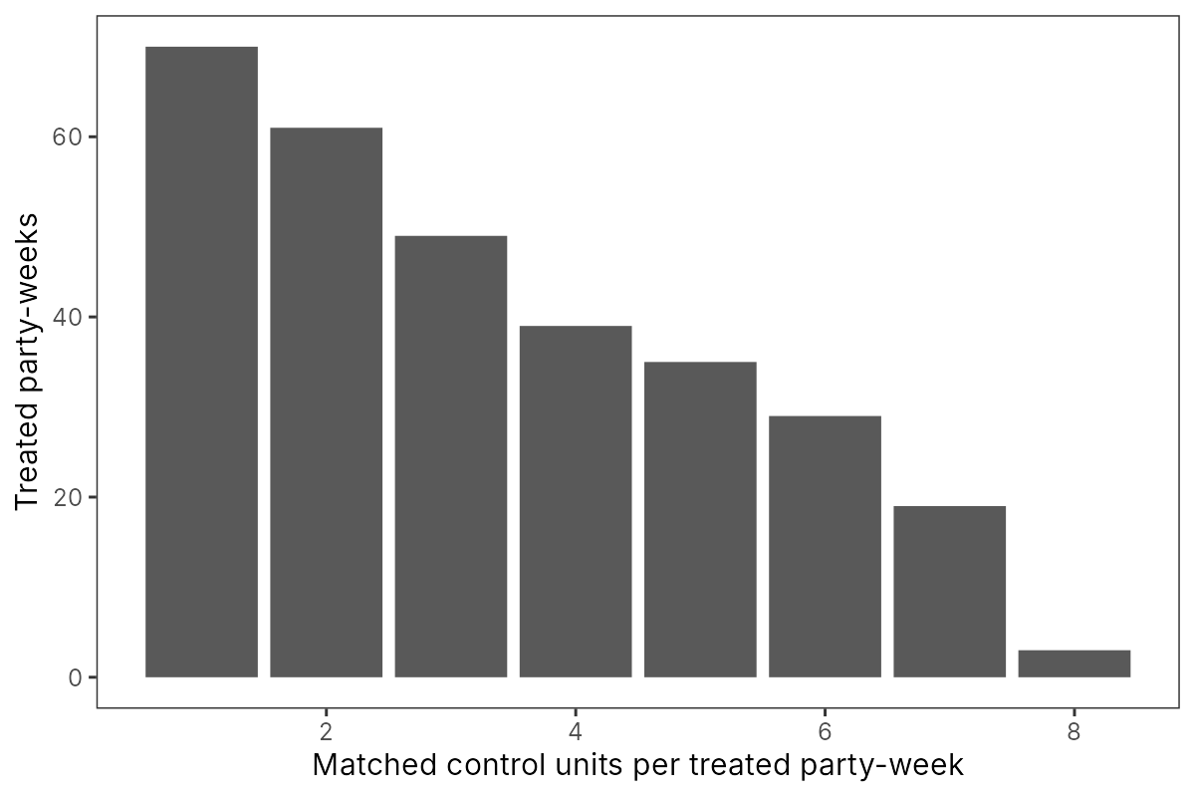
But class never disappeared. Although commentators such as Francis Fukuyama (2012 [1992]) were ready to pronounce the “end of history” and, similarly, an end to class divisions, this did not come to pass. Instead, new forms of contentious politics have emerged, both at the left and right sides of the political spectrum. Perhaps the most successful, and persistent, example is the populist radical right-wing parties, which started to emerge in the mid-1980s and that has spread and grown in size throughout the years. In an increasing amount of countries – Austria, Switzerland, Denmark, Italy, the Netherlands – populist radical right-wing parties have become pivotal players in the building of parliamentary majorities (Afonso 2015; Mudde 2019), and looking outside of Western Europe, radical right-wing parties and politicians have reached executive positions in e.g. Poland, Hungary, Brazil, and the US. Scholars disagree on whether it is primarily socio-economic grievances (e.g. Kriesi et al. 2008, 2012; Kitschelt 1995) or a cultural backlash (e.g. Norris & Inglehart 2019) that fuels the populist radical right-wing parties, but across these camps a consensus has emerged on the “proletarisation” of the populist radical right’s electoral base (Rydgren 2013; Bornschier 2018; Oesch & <!-- page 9 (printed p. 2) --> Rennwald 2018). In other words, the relative share of working-class voters among the electorates of populist radical right-wing parties has tended to increase over time (Arzheimer 2013). Without the strong support of working-class voters, the populist radical right-wing parties would have been much smaller and their political influence would likely have been rather marginal. According to Oesch and Rennwald (2018), about a half of their electorate is found among production and service workers.
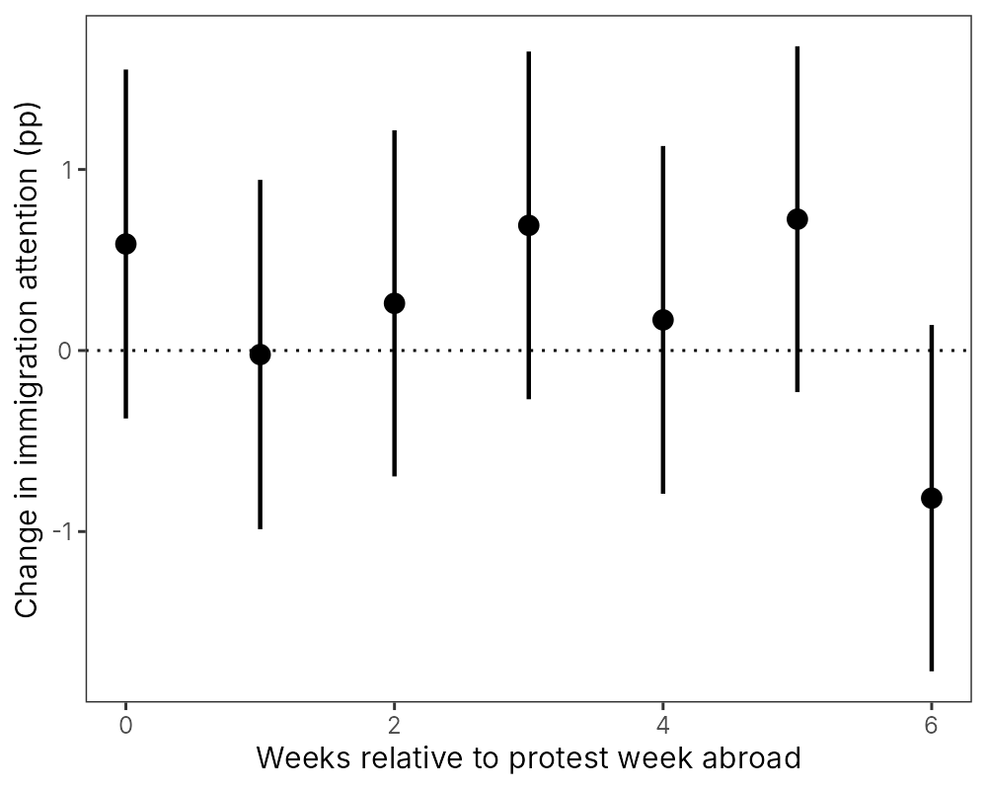
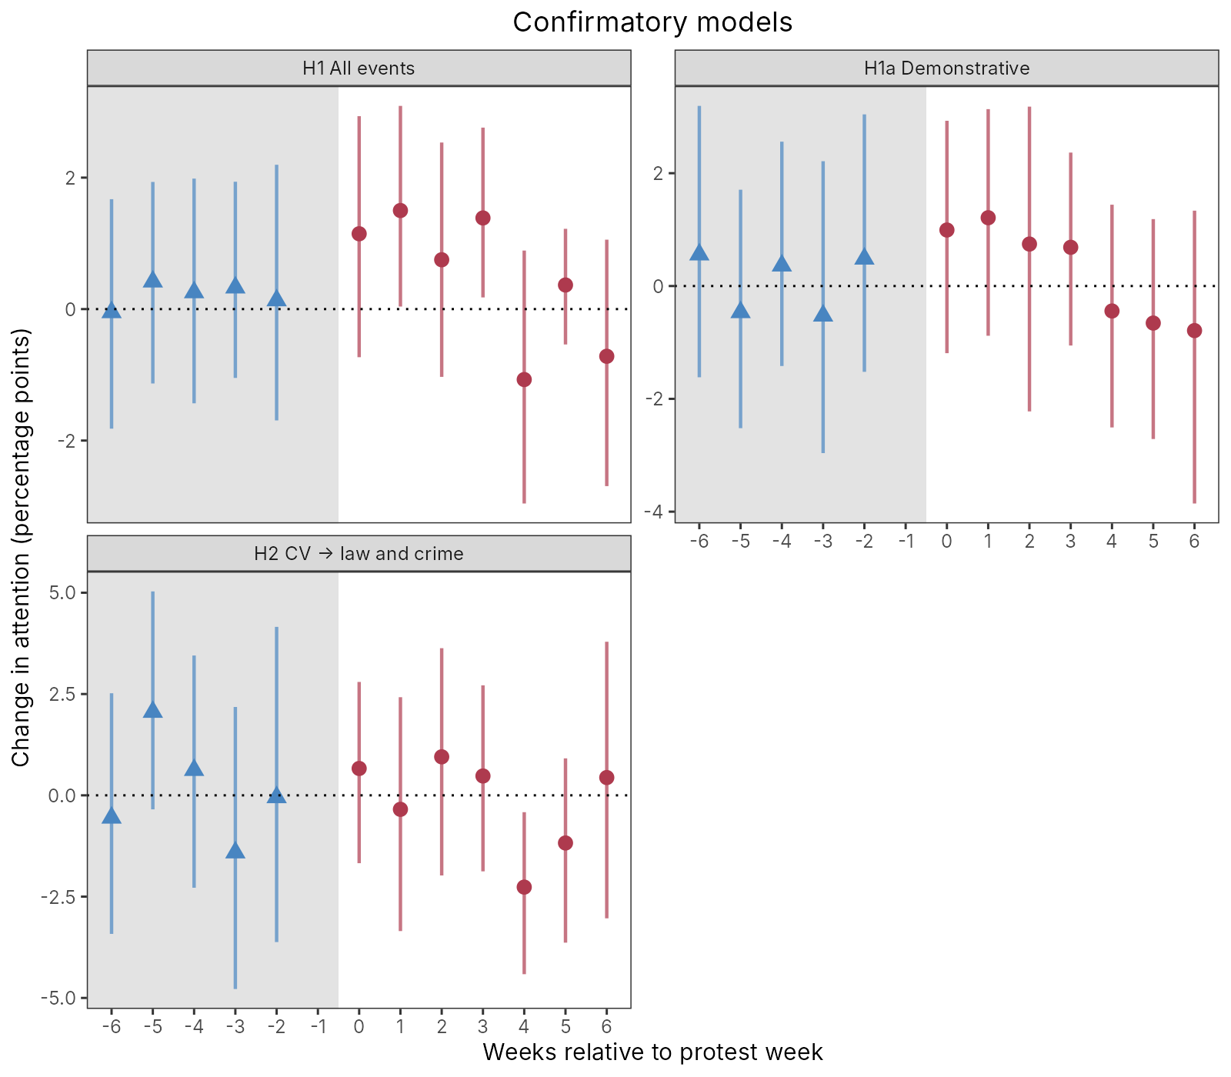
The rise of the populist radical right has been accompanied with a drastic decline in the average vote share of Social Democratic parties across Western democracies. For example, the Social Democrats have in the past two decades lost 8.1 percentage points in support in Sweden, 5.2 in Finland, 16.4 in France, and a full 20.4 percentage points in Germany. As was mentioned above, the apparent dealignment between voters and the centre-left parties led some scholars to conclude that class position no longer matters for voting choice. Yet it has become clear in the recent decade that inequalities between socio-economically, spatially, and ethnically divided groups in Western societies are still persistent (e.g. Piketty 2014) and continue to matter for political outcomes. Hence, scholars such as Kitschelt and Rehm (2015) and Oesch (2008, 2013) have modified the earlier argument, stating that class continues to matter, even though the preferences and voting choices of class segments may be different today than in the past. As Gingrich and Häusermann (2015: 52) put it, there has been “electoral class *realignment*, not *dealignment*.”
One of the crucial questions is how these de- and realignment processes happened and why they vary across countries: in other words, how the shift of working-class voters from the left to the populist radical right came to be. This is where the present book comes in. While much of the previous literature has been looking primarily on social and economic factors, in this book we focus on the importance of political factors. More specifically, we analyse the active agency of the centre-left parties (Social Democrats) and trade unions as well as the populist radical right-wing parties, in bringing about the observed electoral realignment. More specifically, the book asks which programmatic and strategic responses the Social Democrats have deployed in response to the populist radical right-wing parties’ mobilization of parts of their core constituencies? We hence emphasize the strategic supply-side of electoral politics in mobilizing working-class voters. A key contribution the book makes is also to emphasize the role of trade unions in the re- and dealignment processes. Our expectation is that strong unions, associated with the political left, may sustain working-class identities and work as a shield against populist radical right-wing party mobilization (Cf. Kriesi 1999; Rennwald 2020; Rydgren 2002).
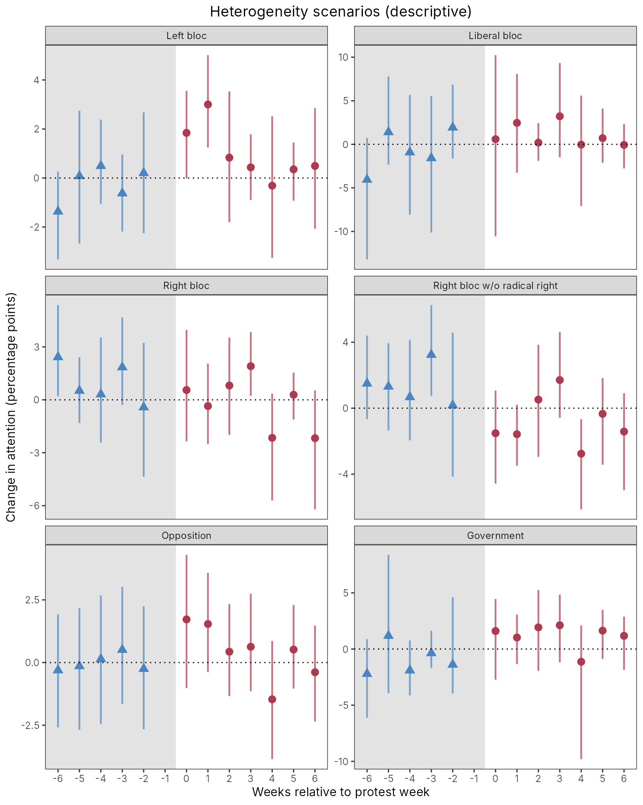
The book looks at contemporary class politics in a very particular geographical location, the Nordic countries. This is because the Nordic countries, once the emblematic loci of Social Democracy, including strong labour parties and encompassing union coverage, are now striking examples of the decline of the centre-left, weakening union organization, and the parallel rise <!-- page 10 (printed p. 3) --> of the populist radical right. The average vote share of Social Democratic parties in the Nordic countries – Sweden, Finland, Norway, and Denmark – was 33.9 per cent in the 1990s: by the 2010s, it has dropped to 25.3 per cent. In Sweden, the decline is even more drastic, as the Social Democrats’ vote share has dropped from 45.3 per cent in 1994 to 28.1 per cent in 2018. The opposite is true for the populist radical right. While in the 1990s these parties reached, on average, 6.2 per cent of the vote in the Nordic countries, in the 2010s they got 14.9 per cent. Hence, while the Nordic Social Democratic parties still are comparatively strong, we believe that their notable decline, coupled with the rise of the populist radical right, makes the Nordic countries an illustrative case of a dynamic process, which is presently taking place across the Western democracies: the crisis of the centre-left and the parallel rise the populist radical right.
In this introductory chapter, we do three things. First, we explain why, theoretically, we should expect political competition between the centre-left and the populist radical right, and formulate some expectations about how this competition might look like. Second, we motivate our case selection. We demonstrate the patterns of centre-left decline and the growth of populist radical right-wing parties in the Nordic countries, and we show how these political groups to a large extent compete over the same voters. We also briefly introduce our case studies. Third, we lay out our argument and our specific research questions. The rest of the book is dedicated to the case studies – Sweden, Finland, Norway, and Denmark – and finally, the last chapter discusses the findings and concludes.

### The centre-left and the radical right – a new cleavage?
In this section we want to further motivate the purpose of this book. Why should we study electoral competition between the populist radical right and the centre-left parties, particularly? After all, the classic spatial theory of party competition (Downs 1957) would predict parties to compete based on proximity along the socio-economic, left-right axis. According to this theory, then, we would expect competition particularly between the centre-right and the radical right.
Research has indeed demonstrated that the movement of working-class voters between the centre-left and the populist radical right is no straightforward phenomenon. Rennwald and Pontusson (2017) have studied the behaviour of voters who have abandoned the centre-left, asking two questions: which group of voters is it that abandons the centre-left, and to which party do these voters go? The important thing to note is the premise that centre-left, Social Democratic parties today struggle with an electoral dilemma, a trade-off between a working-class and middle-class constituency. The working class has, in recent couple of decades, increasingly been replaced by the middle class, as the centre-left’s core electorate (see also Gingrich & Häusermann 2015: 44). Yet, in order for the Social Democratic parties to <!-- page 11 (printed p. 4) --> retain their vote shares, they need both the middle- and working-class voters, and therefore oftentimes appear divided, trying to balance between the distinct preferences of these voter groups. Rennwald and Pontusson (2017) conclude that the class profile of the centre-left party matters for the potential defectors. If the centre-left party retains a strong working-class profile, the propensity of particularly the unionized workers to leave declines. But if the party has a strong middle-class profile, then working-class voters are more likely to leave. Second, they show that almost half – some 45 per cent – of those who leave a centre-left party do, in fact, move to vote for the centre-right, while only 8 per cent go on to vote for the radical right. This would suggest merely weak electoral competition between the centre-left and the populist radical right. Yet, Rennwald and Pontusson’s dataset does not include the most recent years, and the authors acknowledge that the direct competition between the centre-left and the radical right is likely to have increased since then. Our results back this conclusion. In our country cases, we see that up to early 2010s, the centre-left parties tended to regard the centre-right as their main adversary, but in the most recent years, the direct threat from the populist radical right has been noticeably stronger. Hence, we have reason to expect significant political competition between the centre-left and the populist radical right.
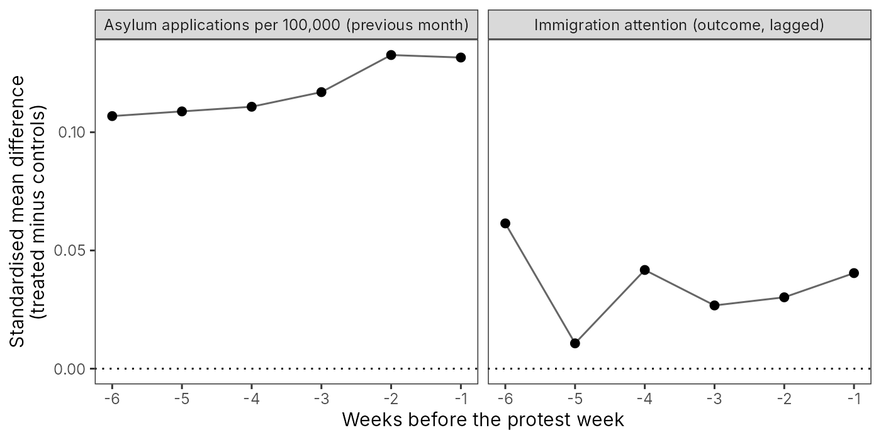
But why? Why do working-class voters choose to vote for the radical right? Of paramount importance here is the increased salience of socio-cultural political issues, relative to the socio-economic ones. The “new politics” literature has long acknowledged the existence of a new, cultural conflict dimension in Western democracies. According to Judith Stein (2010: 13), as of the late 1960s, “[p]ostwar prosperity altered the analysis of modern society (and) [a]ffluence fostered new thinking about leisure, human relations, consumerism and a host of extra-economic concerns.” Starting from the university campuses of the United States, a cultural revolution began to transform the post-war structure of political conflict. New social movements and the New Left – socialist, Green – parties politicized issues pertaining to new values and lifestyles, such as gender and sexual minority rights. Over time, this new, socio-cultural issue dimension acquired a position as a second major axis of political competition, cross-cutting the left-right distributive one. As a result, the established parties and their electorates, with preferences organized along the socio-economic left-right axis, began to experience growing internal friction. This was particularly consequential for the centre-left parties. Namely, in an environment of growing prosperity, the assumption became that “historic conflicts between capital and labor had been resolved” (ibid). Class politics seemed to be losing relevance. The Left and centre-left parties, traditional carriers of class grievances, accordingly began to emphasize the socio-cultural issue dimension in their political offer. In doing this, they were also reacting to the above-mentioned changes in their voter constituencies, where the old manual working class was decreasing in size and being replaced by the growing ranks of middle-class professionals (e.g. Bornschier & Kriesi 2013). The latter group <!-- page 12 (printed p. 5) --> tended to hold much more liberal attitudes towards socio-cultural issues than did the working class, and it was to them the New Left was now speaking. Yet, as also the Social Democratic parties moved to a New Left direction, the old working class was left with less representation than previously, both in the socio-economic and the socio-cultural dimensions. Sensing this void in party offer, as of the 1980s, the new populist radical right-wing parties mobilized the left-behind groups of working- class voters with a traditional-authoritarian socio-cultural agenda. What emerged was the GAL–TAN[^ch1-1] axis of political competition, pitting the alternative-green-left parties against traditional-authoritarian-nationalistic ones (Kitschelt 1994; Hooghe & Marks 2009). A main thing to observe, therefore, about the populist radical right-wing party voting is that voters choose these parties primarily based on their policy positions along the socio-cultural GAL–TAN axis, rather than the socio-economic one. Along this socio-cultural axis, anti-immigration attitudes and nationalism, in particular, unite radical right-wing voters whilst also low trust in political institutions plays an important role (Rydgren 2008; Arzheimer 2018).
Who then are these voters, united behind the socio-cultural program of the populist radical right? Research has demonstrated that there are important socio-demographic patterns in radical right-wing support. Male voters (Coffé 2018), working-class voters (Rydgren 2013; Bornschier 2018) and, to an extent, small business owners are overrepresented among populist radical right-wing parties’ supporters, as are lower educated voters (Ivarsflaten & Stubager 2013; Oesch & Rennwald 2018). By contrast, highly educated voters, in particular socio-cultural professionals, such as employees in the health care, education, social welfare, and the media sectors, are underrepresented (Ivarsflaten & Stubager 2013; Kitschelt 2018; Lubbers et al. 2002). However, this relationship seems to be curvilinear: the populist radical right receives its strongest support from the mid-school stratum (Arzheimer & Carter 2006; Evans 2005). Notably, with respect to these socio-demographic patterns – gender, education, professional, and socio-economic status – the electorates of the populist radical right and the contemporary centre-left tend to represent mirror images of each other. The working-class electorate is the overlapping constituency that these voter groups compete over, but otherwise, both in terms of issue positions and electorates, we would expect the centre-left and the populist radical right to be rather dissimilar.
Of key interest for this book is to understand by which means the populist radical right has been able to secure such exceptionally high support among the working class, in particular. This is a key factor in understanding the success of the contemporary radical right in general: had these parties not been able to make such inroads among this segment of the electorate, they would have been more marginal in size – after all, about half of their electorate is found among production and service workers (Oesch & Rennwald 2018: 11). Our argument is that this hinges on the consistently high salience of socio-cultural politics, which the populist radical right-wing parties have been <!-- page 13 (printed p. 6) --> successfully advocating. In other words, issue competition behind the relative saliences of the socio-cultural and socio-economic conflict dimensions is paramount to the relative decline of the centre-left and the sequential rise of the populist radical right. The argument combines the two main strands of explaining the radical right’s electoral success: one focusing on the demand-side of politics and the other on the supply-side. The macro-structural changes described by the demand-side school have been important in de-politicizing socio-economic conflict; yet, the structural changes only become political reality via deliberate political agency. Therefore, the supply-side of politics is paramount to explaining the rise of the populist radical right.
In order to spell out our argument, let us briefly go through the two main schools of thought used to explain the electoral fortunes of the radical right. The first centres on changes in the demand from the electorate, which then affects voting behaviour. Here, the literature is somewhat divided between the economic and cultural explanations. The *economic* demand-side explanation for radical-right voting tends to be rooted in the so-called grievance theory (e.g. Koopmans et al. 2005), where the argument is that the large structural changes, such as globalization and post-industrialization, which have hit Western societies in the past couple of decades, have increased feelings of discontent and grievance among the population. These changes have treated population groups differently, thus creating new groups of “winners” and “losers.” Among the losers are workers that had relatively secure positions in the industrial society, such as the manual working class in the male-dominated, heavy industry. As Afonso (2015: 274) has observed, the profile of a typical, contemporary populist radical right-wing voter is that of a “low-skilled labour market insider,” referring to the “traditionally left-leaning low-skilled workers in secure employment, such as blue-collar male workers from the private sector and low-skilled workers in sheltered professions.” Labour markets in the post-industrial society have been characterized as dualized, segmented, or fragmented (e.g. Betz 1994; Beck 1992). In post-industrial labour markets, groups with different skill levels enjoy noticeably different working conditions, such that highly educated and skilled individuals enjoy good working conditions, high wages, and favourable career prospects, whereas lower educated, unskilled workers face insecure employment, poor working conditions, low wages, and high risk of un- and under-employment. These changes have led to what Dahrendorf (1959) labelled the “decomposition of labour,” where the working class is increasingly divided by skill levels. In the post-industrial economy, labour markets are characterized by a greater emphasis on private services – at the expense of heavy industry – and the accompanying shift to smaller workplaces and irregular employment contracts. As Bartolini (2000: 23) has argued, these processes have resulted in greater workplace heterogeneity, a separation between work and residence that has led to a demise of specific industrial communities, as well as to the decrease in large workplace establishments and to weaker attachment to the labour market.
These structural shifts have been accompanied by a weakening organizational capacity within the working class, particularly in the form of the decline of working-class parties, as well as trade union density. Union organization levels have traditionally been high in the manufacturing industries and the public sector, which are more likely to operate through large establishments, in which the costs of organizing union members are lower and the tradition of joining has been better established. Workplace organizations – union clubs – have been important in establishing a social custom whereby joining the union is the norm and their existence has been strongly associated with higher union density (Bryson & Gomez 2005; Kjellberg 2001). By contrast, private services generally operate through smaller establishments in which the costs of organizing members are high, the tradition of joining is less well established, workplace organizations in the form of clubs are rarer, and employer resistance is considerably higher (Checchi & Visser 2005; Ebbinghaus et al. 2011; Schnabel 2013). Besides strong unions, facilitated by workplace organization, the heyday of the industrial era also saw the growth and increasing influence of working-class parties. Again, aside from functioning as political representatives of working-class interests in parliaments, these parties typically constituted important social actors as well, in organizing social events and study groups for its members and their families. As working-class parties and, above all, trade unions function as important actors fostering class consciousness and collective class identities among the working class by framing issues and grievances in accordance with working-class ideologies and class interests (e.g. by promoting common economic interest among the workers, and by promoting antagonistic relations between workers and employers) (Betz 1994; Hechter 2004; Kelly 1998), the strength of these organizations greatly contributed to strong and salient class politics. Finally, “worker” is not only a position in the occupational structure, but also an identity. In the industrial era, workers typically shared similar housing, working, and living conditions, and their educational levels were often on par with each other. As they commonly worked in, and lived nearby, large factories in industrial communities or in the cities, they were also to a high degree socially isolated from individuals belonging to other social classes, and social interaction between classes was rare. The impermeability of class borders and the significant similarity in the everyday experience of workers contributed to a clear distinction between the working class and other classes, and created strong bonds and emotional ties within the class (Bartolini 2000). The commonly shared culture was another factor in promoting strong class consciousness and collective class identities.
The important takeaway for our purposes here is that the structural changes, described above, have weakened the preconditions for salient class politics by corroding the organizational capacity and collective identity of the working class in multiple ways. As the cultural and economic ties between workers have become looser, class voting has also declined in importance. Consequently, segments of the working class have become available for mobilization by the populist radical right.
Besides the economic demand-side explanation, also *cultural* factors have been used to explain the electoral success of the populist radical right. As briefly mentioned above, there has been a broad and widely documented value shift in affluent Western societies towards the direction of socially liberal values (e.g. Norris & Inglehart 2019). As Norris & Inglehart (ibid., 33) describe, the cultural shift has “brought greater emphasis on environmental protection, peace movements, sexual liberalization, democracy and human rights, gender equality, cosmopolitanism, and respect for the rights of homosexuals, immigrants, handicapped people, and ethnic/racial minorities.” But on the opposite side, a backlash in the form of socially conservative values has taken place and found political expression in the populist radical right-wing parties. Simultaneously, the opening up of societies and borders has led to increased immigration and thereby, cultural diversity in Western societies. The increased ethno-cultural diversity together with the increased value diversity has strengthened the hand of the populist radical right, as a reaction against the cosmopolitan-liberal elites who, allegedly, have brought the value shift about. In sum, these cultural changes have led to a higher salience of the socio-cultural issue dimension, as compared to the socio-economic one, which has advantaged the populist radical right.
The rise of socio-cultural politics is related to de- and realignment processes, where the ties between voters and parties change and the cleavage dimensions, based on which parties mobilize voters, change in relative salience. In the beginning of this chapter we said that a key contribution of this book is to explore *how* the de- and realignment processes between the working class and the centre-left and populist radical right-wing parties happened. This is where we bring in the second type of explanation used to account for the rise of the populist radical right: that focusing on the political *supply-side*. In the context of radical right research, supply-side explanations focus on how the strategies of established parties enabled radical right-wing political entrepreneurs to exploit new preferences among the electorates (Kitschelt 2018). The supply-side explanations amend the grievance theories, described above, by emphasizing that voters will defect from the established parties only if these fail to supply policies valuable to the potentially defecting voters and/or dismiss the grievances related to the structural economic and cultural changes. Hence, the supply-side explanations point out that to explore the conditions under which the populist radical right succeeds, we need to look at what the established parties do or fail to do. Bornschier (2018) has, moreover, called for scholarship that “combines study of long-term cleavages with the more short-term strategic perspectives of political parties” and looks at how political actors, with their conflictual relationships, shape the “processes of de- and realignment within certain social groups.” In this book, we seek to fill in the gap identified by Bornschier by looking at the strategic actions of Social Democratic parties and trade unions in reaction to the electoral threat of populist radical right-wing parties.
A key concept in the supply-side literature is that of a political opportunity structure (Rydgren 2005, 2007; Tarrow 1995). In short, in order for new <!-- page 16 (printed p. 9) --> political entrepreneurs to succeed, favourable political opportunity structures need to exist. Of such opportunity structures, among the most important are niches left by the lack of supply from the existing parties, in response to demand from voters. In the discussion above, we mentioned the niche left by the centre-left, working-class parties moving to a New Left direction in their political offer. This can mean these parties adopting an increasingly socio-cultural, identity-political focus and/or changing positions in socio-economic, distributive policies. These changes can occur in response to the growing relative size of the middle class among the centre-left parties’ electorates, or an ambition to increasingly reach out to this constituency. Yet, the result will be a niche established by the working-class voters being left with less representation. Arguably, this is a niche that the populist radical right-wing parties have succeeded to partly fill.
Against the Downsian spatial theory of party competition, Kitschelt (2018) has invoked an issue ownership and valence competition model to explain, from a supply-side perspective, the politics of the radical right’s ascent. With valence competition, he refers to a situation where all parties agree on a common set of political objectives, but compete over “ownership” in the issue; in other words, over which party the voters consider best for delivering the desired policy. Characteristic for such valence competition is that parties will try to advocate the higher salience of issues where they are considered issue owners, and ignore or defuse the political debate from issues that are owned by competing parties. We expect this type of competition to be at the core of the relations between the centre-left and the populist radical right-wing parties in our country case. More specifically, we expect these parties to compete, first, over the relative salience of the socio-economic and socio-cultural cleavage dimensions, and, second, over issue ownership along these dimensions.
Several scholars have pointed to the fact that while core groups of populist radical right-wing voters – workers, lower-middle-class voters (e.g. artisans and craftsmen), and other small business owners with relatively low levels of education (sometimes called the *petite bourgeoisie*) – differ in their preferences for economic policies, they tend to share preferences for cultural policies, encompassing issues such as nationality, migration, sexuality, and law and order, to a considerably higher degree (e.g. Afonso 2015; Oesch & Rennwald 2018). As a result, these voting groups tend to support populist radical right-wing parties predominately when cultural preferences, in particular issues pertaining to national identity and immigration, are of high salience (Ivarsflaten 2005; Spies 2013). When socio-economic preferences are of higher salience relative to socio-cultural preferences, and when the capacity of class organization is strong, working-class voters are more likely to support centre-left parties, while petit bourgeois voters are more likely to support a centre-right party (Spies 2013). Given this, we expect the first instinct for the centre-left parties to try to increase the salience of socio-economic at the expense of socio-cultural issues, because the former is where they have issue <!-- page 17 (printed p. 10) --> ownership. Yet, in case socio-cultural politics are highly salient, the centre-left parties will also try to gain ownership in issues such as immigration or law and order. The reverse is true for the populist radical right: while the populist radical right benefits from the high salience of socio-cultural politics, they do actively compete with the centre-left also on socio-economic issues.
Following the work of Bale et al. (2010) on, particularly, the responses of Social Democratic parties to the rise of the populist radical right, we may further form expectations of what forms such issue competition may take. According to Bale et al. (2010) the Social Democrats are likely to respond first by a *hold* strategy: holding on to their ideological beliefs and trying this way to win the argument. An example of *hold* would be the Social Democrats steadfastly defending internationalism and a relatively generous refugee politics against the anti-immigration views of the populist radical right. Second, the party can try to *defuse* the populist radical right’s preferred issues by simply not agreeing to take political positions on it. Resetting the political agenda with defuse, the mainstream party can try to increase the salience of its own preferred issues. Bale et al. (ibid) also observe that the defuse strategy could involve seeking a cross-party “pre-emptive consensus” on radical right issues, and hence silence any political debate on the subject. Third, the mainstream party can *adopt* the position of the competitor. This strategy is the polar opposite of the *hold* option, in that it requires the – in this case, Social Democratic – party giving up its ideological integrity for vote-seeking reasons. In the case of immigration, for example, the Social Democrats could try to “close down the issue space on authoritarian-liberal dimension by arguing that migration must be limited and multiculturalism tempered by an increased emphasis on what some call integration (...)” (ibid, 413). Bale et al. (ibid) try to predict a chronological sequence of the options available for the mainstream, centre-left parties. Given strong tradition of Social Democracy in many Western European political systems, they expect the Social Democrats to first try to *hold* on to their ideological beliefs and not “give up at the first hint of a challenge.” Yet, when the Social Democrats deem the populist radical right to have become a significant electoral challenge, they might try an alternative strategy, to *defuse* the competitors’ favoured issues. Only when the populist radical right is likely to contribute to the forming of centre–right coalitions, however, would the Social Democrats be alarmed enough to consider *adopting* the competitor’s position.
From these theoretical premises, we can derive the following expectations regarding the responses of the Social Democratic parties and trade union confederations to the populist radical right-wing parties in our country cases. First, given the relatively long history of populist radical right-wing party presence in Norway and Denmark, we do not expect a strategy of complete dismissal to be available for the Norwegian and Danish labour movements. By contrast, we expect the socio-cultural axis of political competition to have long become a matter of normal politics in these countries, and we expect to find a “pre-emptive consensus” (Bale et al. 2010) on issues of immigration <!-- page 18 (printed p. 11) --> and national identity that has been established already before or in the beginning of our observation period. Hence, we expect valence competition between parties in the socio-cultural issue axis. In the face of electoral pressure and the possibility of populist radical right-wing party government participation, the Social Democrats may also decide to *adopt* parts of the populist radical right’s political offer. In the socio-economic axis, we expect the Danish and Norwegian Social Democratic parties and trade unions to use the *defuse* strategy when advocating a higher salience of socio-economic, distributive politics. Whether this takes place, however, is likely to vary over time, depending on party strategy.
Second, in Sweden and Finland, we know that the ascent of the populist radical right as a serious political adversary took place only in the late 2000s and early 2010s. Hence, in the beginning of our observation period – early to mid-2000s – we expect the Social Democrats and the trade unions to at least try to apply the strategy of dismissing the radical right. In the Swedish case, given the country’s strong tradition of class politics and the prevalence of the socio-economic left-right axis, we then expect the Social Democrats to try to both hold on to their ideological principles in both the socio-economic and socio-cultural dimensions, as well as to try to defuse the political debate such that the socio-economic dimension would retain its strong status. We expect Sweden to be the least likely case of the labour movement giving in and adopting the radical right’s programmatic offer, albeit towards the end of our observation period, when the Sweden Democrats’ support rose to a tie with the Social Democrats, the electoral pressure may have prompted the party to do so. Finland, on the other hand, is characterized by a more pragmatic political culture, where cross-class alliances in government are not unknown. We thus expect the Finnish labour movement to relatively early take issue with the populist radical right-wing Finns Party, and to show willingness to compromise on its own ideological positions in order to cooperate politically. Depending on leadership and strategic changes in the Social Democratic party, we expect to see variation between periods of the defuse and adopt strategies.
We now move on to introduce and motivate our case selection, followed by a description of the methods and data used for this book.

